VITyarthi - PYTHON ESSENTIALS - PROJECT REPORT
CARBON FOOTPRINT CALCULATOR
Prepared by: PEARL MATHEW
Registration number: 25BHI10014
Institution: VIT BHOPAL UNIVERSITY
Date: ____ November, 2025
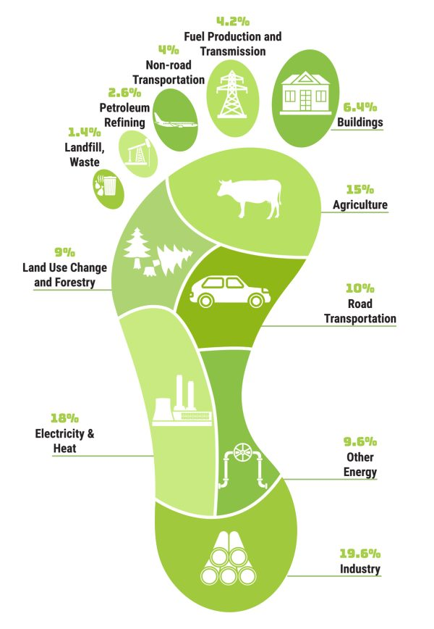

INTRODUCTION
The sustainability of our environment is at risk today, due to high carbon emissions which play a significant role in climate change. Everyday situations, such as energy usage like electricity and fuel consumption as well daily travel contribute to an individual’s or company’s portion of their carbon footprint. The aim of this project – Carbon Footprint Calculator, is to help users take a closer look at one’s footprint and provide them with an easier way to become aware of its impact and making well-informed decisions, namely reducing carbon emission. ​
PROBLEM STATEMENT
Despite all the talk, climate change currently lacks user-friendly tools to easily measure one's carbon footprint from everyday activities. Calculation by hand is laborious and introduces errors, resulting in scant self-assessment and minimal behavior change. What is desired is that there would exist an easy to use graphics-based application that provides useful results while simultaneously placing the user on education regarding his daily emissions. ​
FUNCTIONAL REQUIREMENT
- The app needs to have fields into which users can input their power, gas and transport usage.
- It needs to be generating "total carbon footprint" sum total derived from these.
- It needs to do error checking for incorrect input data.
- Users need to be able reset inputs easily from the app.
NON FUNCTIONAL REQUIREMENTS
- This calculator should have an easy to use graphical interface (GUI) for users of all age groups.
- The application must respond quickly, completing calculations instantly.
- It must provide reliable calculations based on accepted emission factors.
- The application should work on commonly used computer systems.
SYSTEM ARCHITECTURE
The system follows a simple client-side structure, where all calculations and user interactions happen locally.
- User Interface Layer: Built with Tkinter for direct interaction.
- Business Logic Layer: Manages calculations, validation, and control flow within event-driven functions.
- Data Layer: Not applicable in this version, as data is entered and processed temporarily.

DESIGN DIAGRAMS
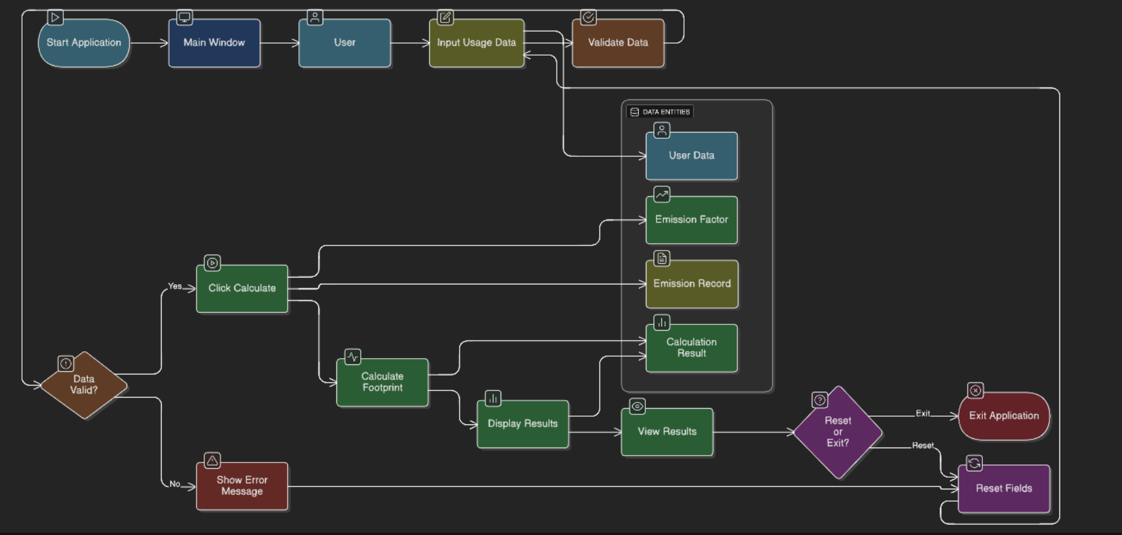

DESIGN DECISIONS AND RATIONALE
The python library 'Tkinter' was chosen by me because it is Python's built in function and is very easy to use for fast GUI development. The application remains simple and responds fast since all calculations happen by the user manually entering the values without needing external libraries or storage. Error handling is included to improve user experience and reliability.

IMPLEMENTATION DETAILS
The project is built using Python program (Anaconda Navigator) using the 'Tkinter' library to generate the GUI. The GUI takes 3 inputs from the user, electricity in kWh, fuel in litres and transport in kilometers, then multiplies each by their respective emission factors, and shows the total carbon footprint in kilograms of CO2. It also includes buttons for reset and exit. Error checking ensures non-numeric inputs are flagged right away, allowing for smoother use.
SCREENSHOTS/RESULTS
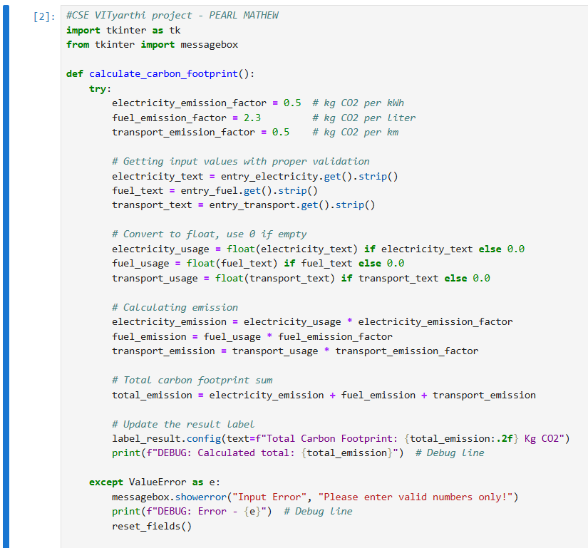
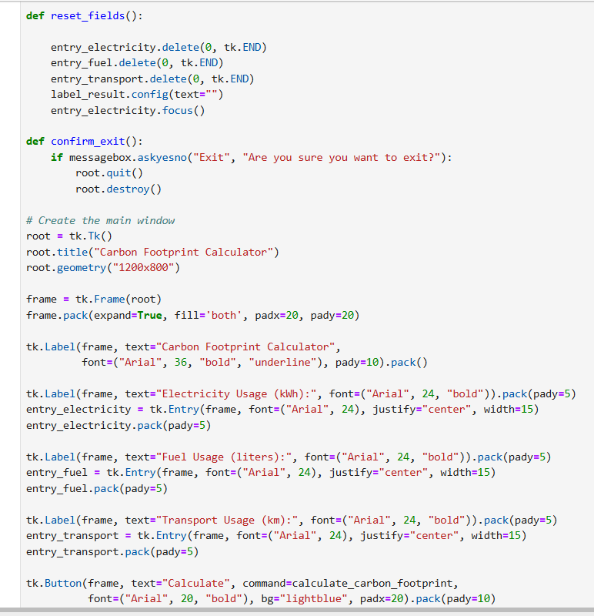
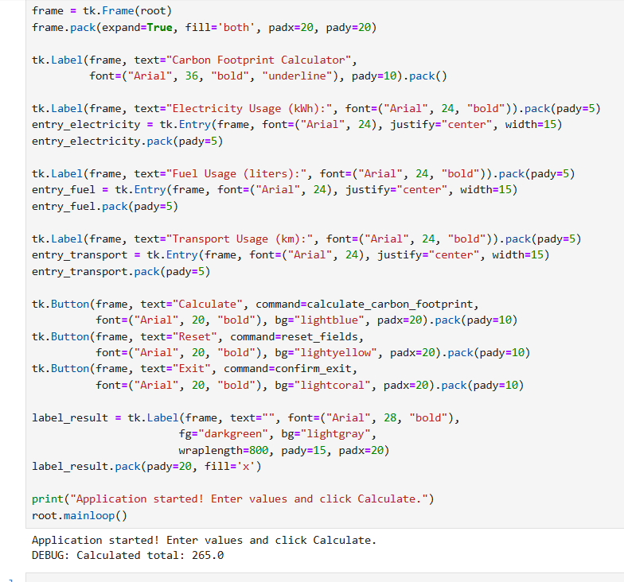
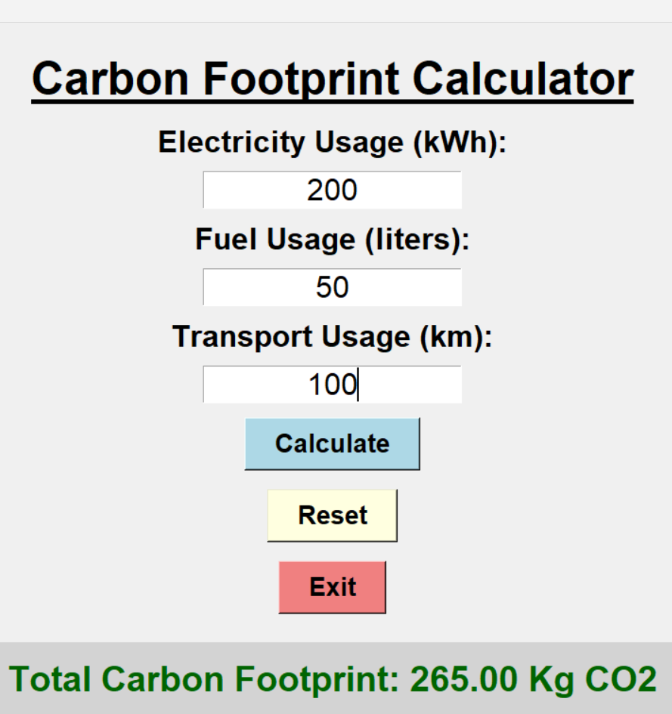
TESTING APPROACH
Testing involved manually entering various valid and invalid values to check calculation accuracy and error handling. Edge cases like empty fields, negative values, and large inputs were considered. The application was also tested for stability while quickly switching input and reset actions and for proper closure using the exit option.
THE CHALLENGES FACED
- Calculating and managing the inputs provided by the users effectively for various given values.
- Ensuring that the application layout is easily adaptable to all devices.
- Trying to make the code informative and good looking

LEARNINGS AND KEY TAKEAWAYS FROM THIS PROJECT
- By making and coding this project, I could gain hands on experience with the 'Tkinter' library and a GUI.
- Learned about emission factors and their importance in environmental calculation tools.
- Recognized the significance of user experience design for the adoption of tools that aim for real-world sustainability impact.
FUTURE ENHANCEMENTS
- Add persistent storage to track usage over time.
- Enable calculations for additional emission sources like flights and appliances.
- Generate printable reports and suggest reduction strategies.
- Provide graphical breakdowns of emissions by category.

REFERENCES
- GSTC 2023 Carbon Footprint Report​
- Carbon Foot Print Calculator by Waddaa Gasim Mohamed​
- Regreener Carbon Footprint Blog​
- The UK's Original & Most Trusted Carbon Calculator​
- Bengal Chamber Project Report Example​

